Week 3 Session 11 Date and Time Handling Concepts
- Java Date and Time
import java.util.*;

public class Solution {

public static String findDay(int month, int day, int year) {

Calendar calendar = Calendar.getInstance();

calendar.set(year, month - 1, day);

String[] days = {
"SUNDAY",
"MONDAY",
"TUESDAY",
"WEDNESDAY",
"THURSDAY",
"FRIDAY",
"SATURDAY"
};

return days[calendar.get(Calendar.DAY_OF_WEEK) - 1];
}

public static void main(String[] args) {

Scanner sc = new Scanner(System.in);

int month = sc.nextInt();
int day = sc.nextInt();
int year = sc.nextInt();

System.out.println(findDay(month, day, year));

sc.close();
}
}
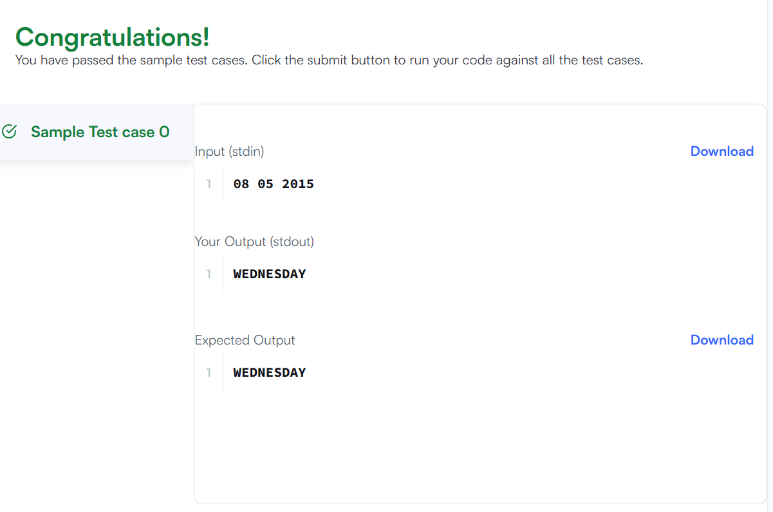

- Number of Days Between Two Dates
class Solution {

public int daysBetweenDates(String date1, String date2) {
return Math.abs(toDays(date1) - toDays(date2));
}

private int toDays(String date) {

String[] parts = date.split("-");

int year = Integer.parseInt(parts[0]);
int month = Integer.parseInt(parts[1]);
int day = Integer.parseInt(parts[2]);

int totalDays = 0;

// Add days for previous years
for (int y = 1971; y < year; y++) {
if (isLeapYear(y)) {
totalDays += 366;
} else {
totalDays += 365;
}
}

// Add days for previous months of current year
int[] daysInMonth = {
31, 28, 31, 30, 31, 30,
31, 31, 30, 31, 30, 31
};

for (int m = 1; m < month; m++) {

totalDays += daysInMonth[m - 1];

// February has 29 days in a leap year
if (m == 2 && isLeapYear(year)) {
totalDays++;
}
}

// Add current day
totalDays += day;

return totalDays;
}

private boolean isLeapYear(int year) {

return (year % 400 == 0) ||
(year % 4 == 0 && year % 100 != 0);
}
}
